**AWS RDS**

* RDS – Relational Database Service
* It is a managed DB service for DB use SQL as a query language
* It allows you to create databases in the cloud that are managed by AWS
* Postgres
* MySQL
* MariaDB
* Oracle
* Microsoft SQL server
* Aurora (AWS Proprietary database)
* **Advantage of RDS vs Deploying DB on EC2**
* RDS is a managed service
* Automated provisioning of DB, OS provisioning
* Continuous backups and restore to specific timestamp (Point in time restore)
* Monitoring dashboards – to see if our DB is doing good
* Read replicas for improved read performance
* Multi AZ setup for DR (Disaster Recovery)
* Maintenance windows for upgrades
* Scaling capability (vertical and horizontal)
* Storage backed by EBS (gp2 or io1 type volumes)
* You can’t SSH to RDS Database instances

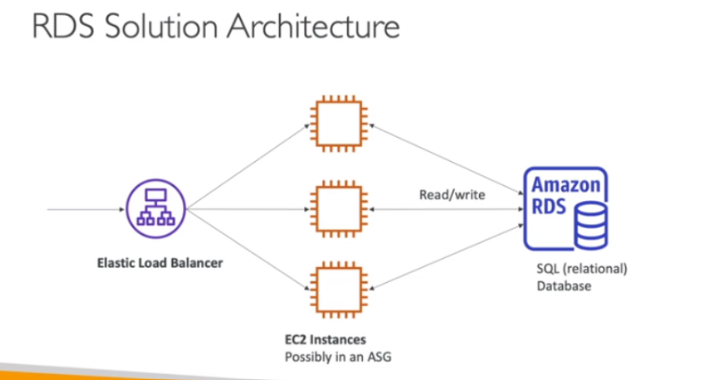

**AMAZON AURORA**

* Aurora is a proprietary technology from AWS (not open sourced)
* Postgres SQL and MySQL are both supported as Aurora DB
* Aurora is “AWS cloud optimized” and claims 5x performance improvement over MySQL on RDS, over 3x the performance of Postgres on RDS
* Aurora storage automatically grows in increments of 10GB, up to 128GB
* Aurora costs 20% more than RDS, but it is more cost efficient
* Aurora is not included in free tier.

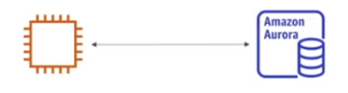

**Amazon Aurora Serverless**

* Automated database instantiation and auto-scaling based on actual usage
* Postgres and MySQL are both supported as Aurora Serverless DB
* No capacity planning needed
* Least management overhead
* Pay per sec – can be more cost effective
* Use cases: -good for infrequent, intermittent, or unpredictable workloads.

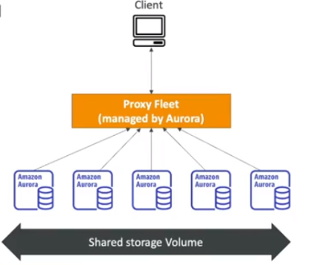

**RDS Deployment:** Read Replicas, Multi-AZ

* **Read Replicas:**
* Scale the read workload of your database
* Can create up to 15 read replicas
* Data is only written to the main DB

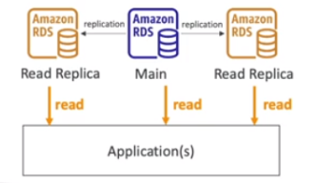

* **Multi-AZ:**
* Failover in case of AZ outage (HA)
* Data is only read/written to the main database. Failover DB will not be accessible until there is an issue with the main DB
* Can only have 1 other AZ as failover

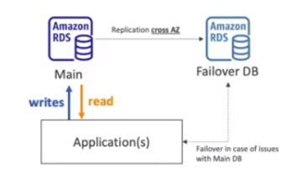

* **Multi Region (Read Replicas)**
* Same as read replicas, but in the different regions
* Disaster Recovery in case of region issue
* Local performance for global reads (less latency based on region)
* Replication Cost will be there since you are replicating data across regions

